**1.Output for Case changer:**

**2.Area of triangle**

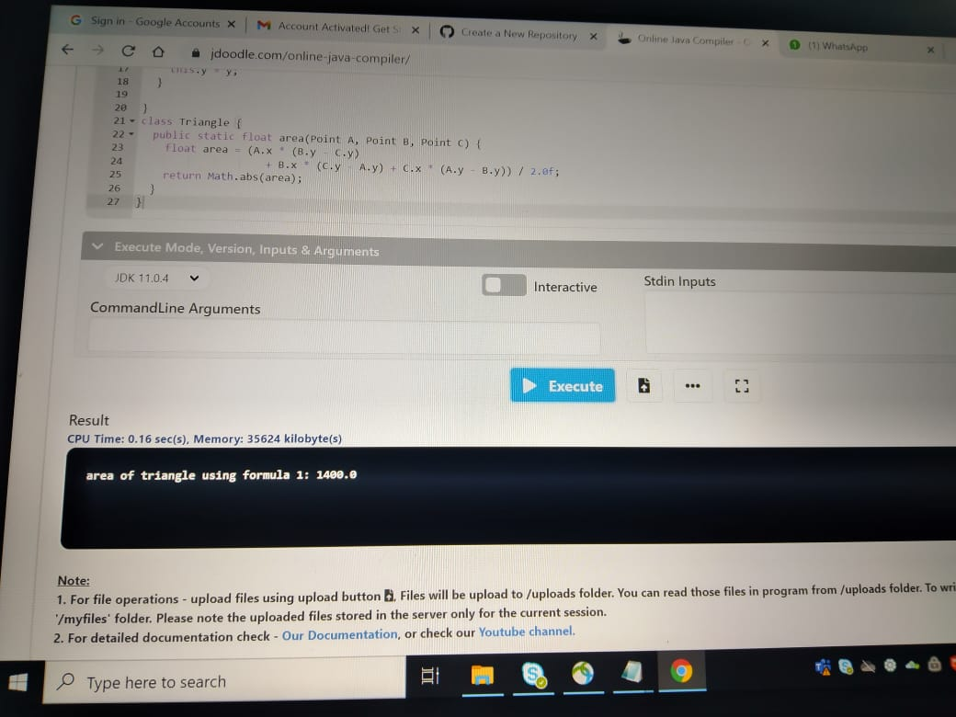

**3.Output for Fibonacci series:**

**4.Output for money management:**

**5.Output for numbers to word:**

